Lesson plan: 7-9 years

Recommended lesson time: 60 minutes

Part 1: The Digital World (10 minutes)

Learning objective: To develop a basic understanding of how to behave when they go online and how to stay safe.

*worksheet*
Think, Pair, Share (10 minutes)
Ask pupils to think about their answers to the following questions, discuss in pairs (5 minutes) and then share with the whole class (5 minutes).

a. Is it OK to share a funny picture of your friend online?
[Teacher’s notes: The friend may not like that image of themselves and their photo is their personal data. Tell children to check with their friends before sharing images or information about them.]
b. Is what you see and read online true?
[Teacher’s notes: There is lots of unreliable stuff out there and it’s not always easy to spot what’s real and what’s not. Advise pupils that if they think anything sounds strange, they should check with an adult who can help them.]
c. What should you do if someone sends you horrible messages by text, social media or instant message?
[Teacher’s notes: Some children may want to respond to them directly. Let them know that they shouldn’t do this. Instead, tell a teacher or another trusted adult they know can help them. They shouldn’t delete the messages so they have evidence to show an adult.]
d. Is it OK to give your password to your best friend?
[Teacher’s notes: Some children may be tempted to share passwords with friends as a form of trust. Advise them that they should always keep their passwords to themselves to keep their personal information safer. They shouldn’t even share it with a best friend.]

Part 2: Being a Digital Citizen (20 minutes)

Learning objectives: To be able to understand what it means to be kind online (and offline). To be able to identify why some people may be ‘unkind’ to others online.

*worksheet*
Activity 1: online kindness (10 mins)

What does it mean to be kind? Discuss and share examples with the class.
[Teacher’s notes: possible answers - doing something nice for someone else, making others feel happy, helping someone in need.]
Ask pupils to write down 3 reasons why some people may be unkind to others when they go online.
[Teacher’s notes: possible answers - it is easier when they can just hide behind a screen; they may want to leave a nasty comment for someone they don’t know like a celebrity they don’t like or a rival football team; people may accidentally get into arguments over games when not face-to-face, people may comment on photos to say mean things because they are jealous; there may be misunderstandings when not speaking face-to-face - leading to arguments and being unkind to others.]
Activity 1: review (10 mins)
Ask pupils to write on a piece of paper 1 kind thing they could do for someone, online or offline.
Collect all the notes and discuss with the rest of the class.

*worksheet*
Part 3: Recovering when things go wrong (30 mins)

Learning objective: To know how and when to seek help to be able to recover if things go wrong online.
When things go wrong, the most important thing is for children to know how to get help and recover from the experience.
Divide the class into groups. Give each group a scenario and ask them to discuss what they think the person should do in each situation to seek help and recover from the experience (10 mins).
Scenario 1
A girl shares the PIN code to her phone with her friends.
A friend takes the phone and deletes photos as a joke.
Scenario 2
A boy is playing an online game with friends but a person he doesn’t know sends messages asking to chat with him. The boy feels worried.
Scenario 3
A girl shares an embarrassing picture of her friend online and this makes her friend sad.
Scenarios 4 - 6
Discussing true or false statements from the Digiworld game
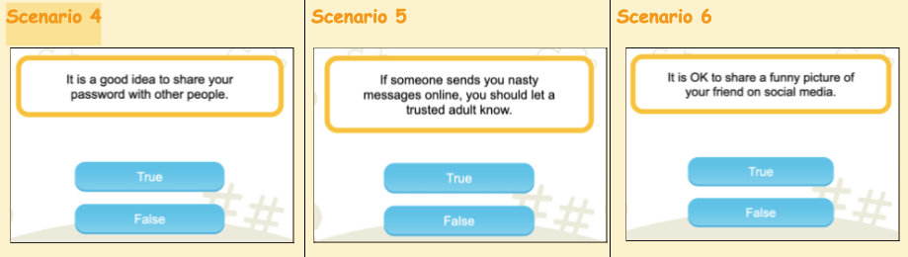
Children who are resilient are more likely to benefit from opportunities online and less likely to experience harm. Resilience isn’t a lesson they can learn in school or a skill they acquire – it must be fostered and nurtured. Parenting and support from trusted adults can make all the difference.
A child who is digitally resilient will be able to:
● Understand when they are at risk online.
● Know what to do to seek help.
● Learn from their experiences.
● Recover when things go wrong.

Ask each group to feed back about their scenario to the class and use this as an opportunity to start a debate (15 mins).
Recap the key points of the debate and introduce the homework activity (5 mins).

*worksheet*
Homework
Encourage parents to get involved in the homework activity so that children can share learning with their families. Parents can help reinforce key internet safety messages and help children to learn how to be safer online.
Ask pupils to answer the true or false statements on the homework sheet.
Direct them to the Digiworld online game https://bit.ly/2RQ8RFq so they can explore all of the topics in more depth.
There are also level 1 worksheets available to download for: Understanding the Digital World, Being a Digital Citizen and Recovering when things go wrong.

