Part one: The Digital World
Are these statements good or bad advice?
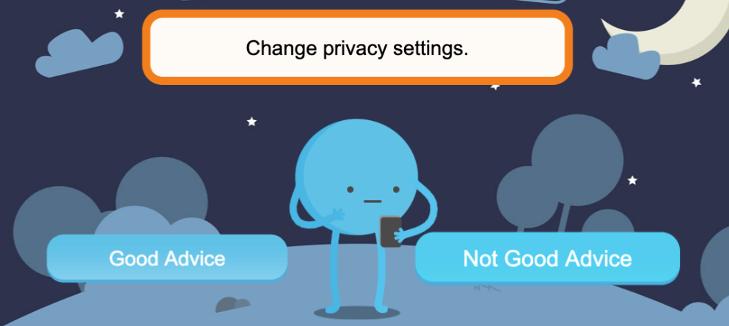
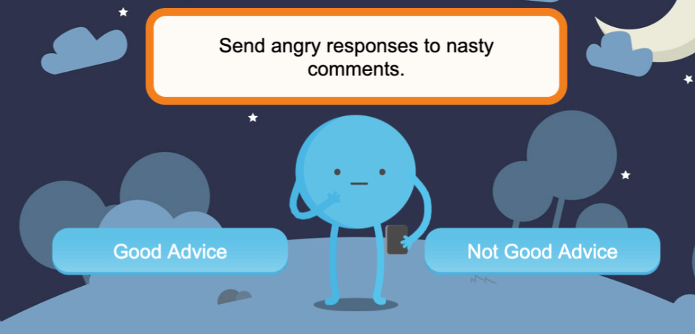
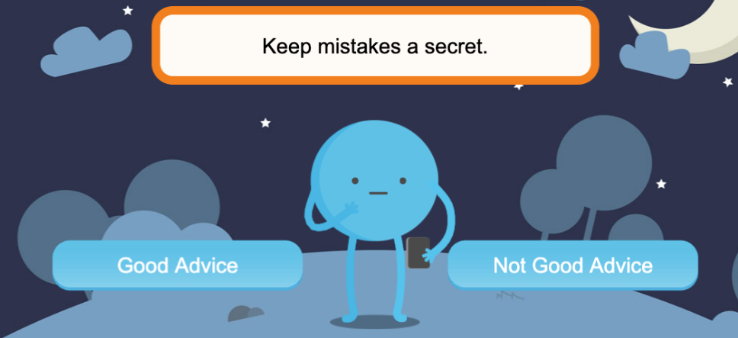
Part one: The Digital World
Talk about these questions:

1.  Why should you stop and think before posting an image of a friend on social media? | 2.  What can you do if you keep getting messages from someone you don’t know? | 3.  What can you do to keep your information safe online?

Part one: The Digital World
Talk about these questions:

1.  Why should you stop and think before posting an image of a friend on social media? | 2.  What can you do if you keep getting messages from someone you don’t know? | 3.  What can you do to keep your information safe online?

