Activity one – online kindness
Read these definition of cyberbullying and trolling:

Cyberbullying | - Bullying online  - People you know  - Face to face bullying often happens as well  - Being unkind a lot online  - For example: not letting you into a game or messaging group, saying and doing unkind things, sharing your address or your crush, name calling
Trolling | - A type of cyberbullying  - Writing nasty and unkind messages to make someone angry or upset on social networks, chat rooms or online games  - Famous people or influencers are targets of trolling  - Trollers use a fake identity or are anonymous

Now, read the sentences and decide where to put the or

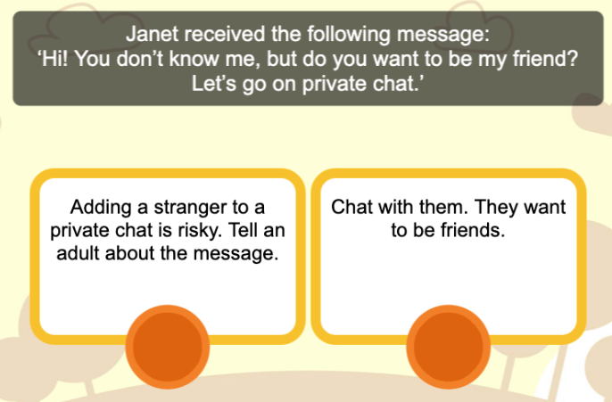
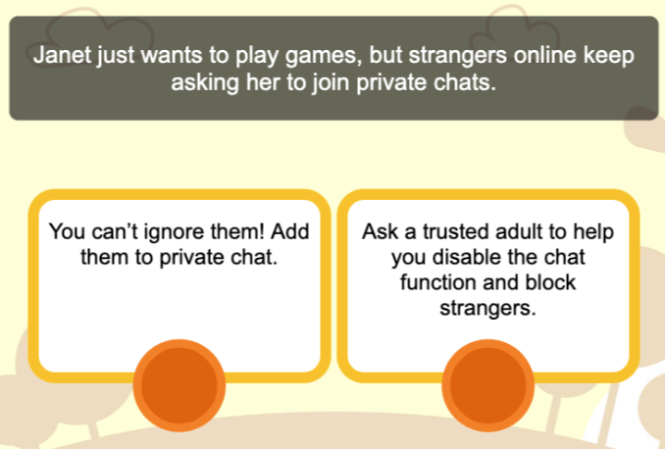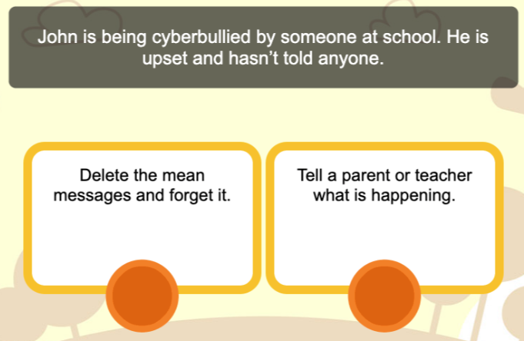
Activity one – online kindness
Read these definition of cyberbullying and trolling:

Cyberbullying | - Bullying online  - People you know  - Face to face bullying often happens as well  - Being unkind a lot online  - For example: not letting you into a game or messaging group, saying and doing unkind things, sharing your address or your crush, name calling
Trolling | - A type of cyberbullying  - Writing nasty and unkind messages to make someone angry or upset on social networks, chat rooms or online games  - Famous people or influencers are targets of trolling  - Trollers use a fake identity or are anonymous

Now, read the sentences and decide where to put the or

