Part three: Recovering when things go wrong
Anybody can make a mistake online. When they do, the most important thing is that they know how to get help and recover.

Create a comic strip about what to do when something has gone wrong online.

Use these top tips to help you:
- Tell a trusted adult if you’ve been tricked
- Tell a trusted adult if you come across anything that upsets or worries you
- Remove any mean posts or embarrassing pictures of other people
- Learn how to block and report people
- Change your password if you think someone else may know it

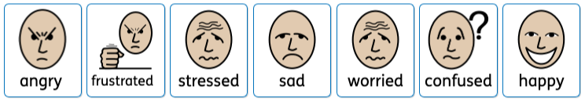
Use the widgets to explain your feelings:

