Part three: Recovering when things go wrong

Scenario 1  A girl shares the PIN code to her phone with her friends.  A friend takes the phone and deletes photos as a joke. | Scenario 2  A boy is playing an online game with friends but a person he doesn’t know sends messages asking to chat with him. The boy feels worried. | Scenario 3  A girl shares an embarrassing picture of her friend online and this makes her friend sad.
Scenario 4  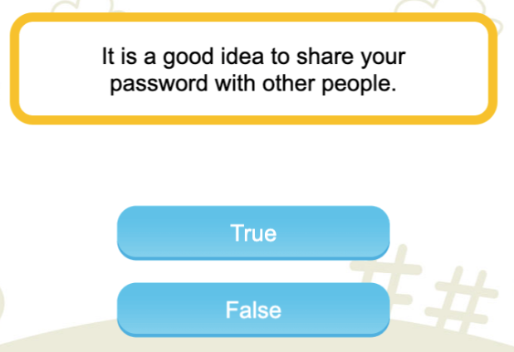 | Scenario 5  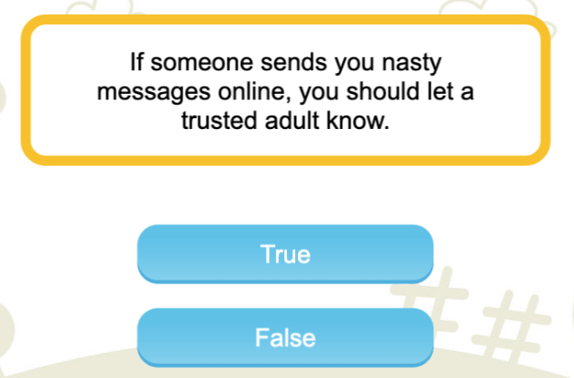 | Scenario 6  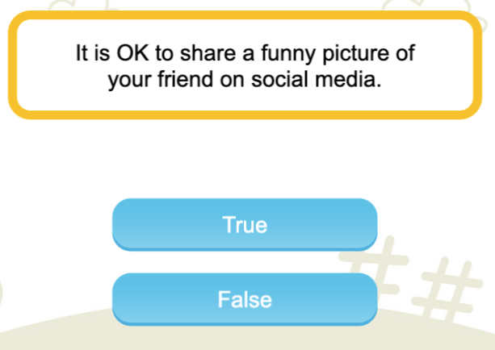

Part three: Recovering when things go wrong

Scenario 1  A girl shares the PIN code to her phone with her friends.  A friend takes the phone and deletes photos as a joke. | Scenario 2  A boy is playing an online game with friends but a person he doesn’t know sends messages asking to chat with him. The boy feels worried. | Scenario 3  A girl shares an embarrassing picture of her friend online and this makes her friend sad.
Scenario 4 | Scenario 5 | Scenario 6

