Homework
We have been learning about how to stay safer online.
Answer true or false for these statements about staying safer online:
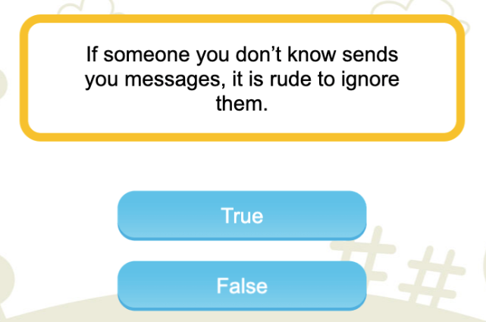
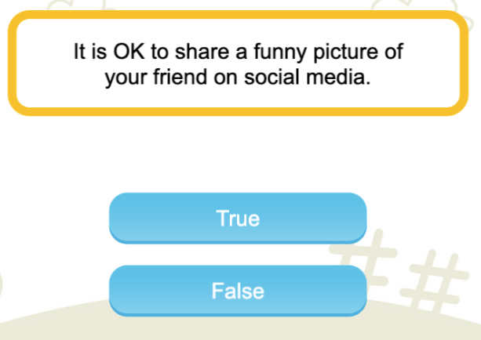
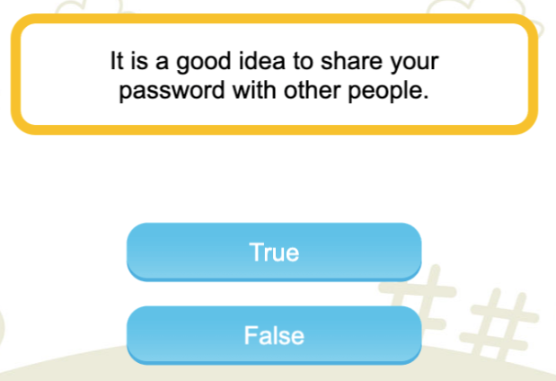

Well done! Now you can play this Digiworld game https://bit.ly/2RQ8RFq
Ask an adult to help you set the right level.

