Lesson plan: 10-12 years
Recommended lesson time: 60 minutes
*discussion sheet*
Part 1: The Digital World (10 minutes)
Learning objective: To be able to understand three different aspects of the digital world including security, online behaviour and commercial.
Split the class into groups and ask each group to discuss these questions about the digital world (five minutes). Discuss each point together as a class at the end (five minutes).
1. What makes a really good password?
2. What should you do if someone sends you unkind messages online?
3. Why do you think Roblox is free to use?
[Teacher’s notes: Answers - 1. Security - Make sure it is easy to remember but hard to guess, use a mixture of numbers, symbols, characters, uppercase and lowercase letters. Use part of a memorable sentence or phrase and avoid obvious things like date of birth and your pet’s name. 2. Online behaviour - Tell a trusted adult so they can help you, report and block the person online, keep evidence of the messages. 3. Commercial - Roblox makes enough money from the adverts that target what you like. Advertisers pay a lot of money to be able to target groups of people that may be interested in what they are selling.]

Part 2: Being a Digital Citizen (20 minutes)
Learning objectives:
● To be able to understand when behaviour may be seen as kind and when it may not be - looking at misunderstandings online.
● To be able to understand when something may be unreliable online - an introduction to fake news.
*worksheet*
Activity 1: online kindness (10 minutes)
Sometimes people don’t realise they are being unkind online. When you’re not face-to-face, things can be easily misunderstood because you can’t see or hear a person saying something out loud. It’s not just about their tone of voice but also their facial expression.
Write this example of a message and ask pupils to say it out loud, changing their tone of voice and facial expression as they speak to make it sound like an insult - and then again to sound like a compliment. Explain how it can be easy to misunderstand a message online. How can they improve this message to make it easier to understand and more obvious that it is meant to be kind? What can they add/change?
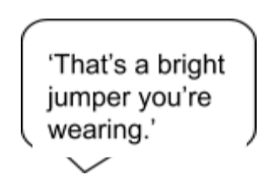

[Teacher’s notes: possible answers - they could add a heart emoji, a thumbs up, say it looks really nice, it suits you, I like it...]
Ask pupils to work in pairs and come up with at least three more examples of messages that could be misunderstood and three ways they could improve the message to make it easier to understand. Share with the rest of the class.
*worksheet*
Activity 2: Spotting unreliable information (10 minutes)
Not all information online will be true. Children need to learn how to work out whether the information they come across is true and reliable.
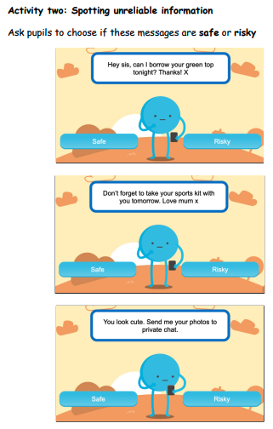

*worksheet*
Part 3: Recovering when things go wrong (30 minutes)
Learning objective: to be able to understand appropriate solutions to recover from online problems and mistakes.
Anybody can make a mistake online. Even if a child is careful, accidents can happen, they may feel unsafe or people might be unkind. When things go wrong, the most important thing is that they know how to get help and recover.
Ask pupils to Draw 4 things that they can do, these ideas will help them:
- Tell an adult you trust
- Show an adult any unkind posts or pictures you’ve shared of other people
- Tell an adult if something upsets or worries you
- Learn how to block and report people online
- Change your password if you think someone else may know it
Teacher’s notes:
Children who are resilient are more likely to benefit from opportunities online and less likely to experience harm. Resilience isn’t a lesson they can learn in school or a skill they acquire – it
must be fostered and nurtured. Parenting and support from trusted adults can make all the difference.
A child who is digitally resilient will be able to:
● Understand when they are at risk online.
● Know what to do to seek help.
● Learn from their experiences.
● Recover when things go wrong.

*worksheet*
Homework
Encourage parents to get involved in the homework activity so that children can share learning with their families by completing the multiple choice quiz.
Parents can help reinforce key internet safety messages and help children to learn how to be safer online.
Task:
Pupils share the quiz sheet with their families and work together to choose the right answer. The answer key is provided.
Direct them to the Digiworld online game https://bit.ly/2RQ8RFq so they can explore all of the topics in more depth.
There are also level two worksheets available to download for: Understanding the Digital World, Being a Digital Citizen and Recovering when things go wrong.

