Part two: Being a Digital Citizen

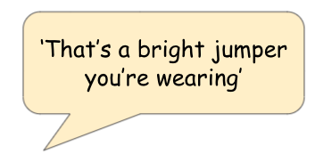
Activity one: online kindness
Use the pictures below to help you say this message in different ways, try changing how your face looks too!

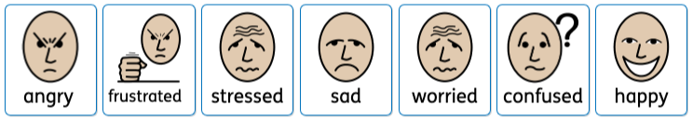

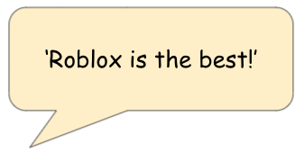
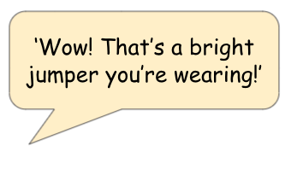
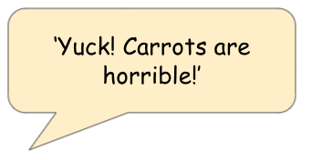
Now, try saying these:

Part two: Being a Digital Citizen
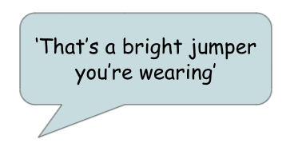
Activity one: online kindness
Use the pictures below to help you say this message in different ways, try changing how your face looks too!

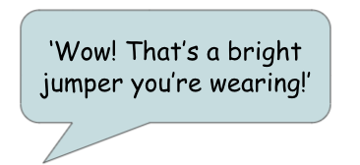
Now, try saying these:

