Meet Ollee
Your virtual friend
Upset about school ? Ollee can help with that!

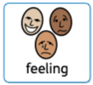
Annoyed by your family ? Ollee can help with that too!

Ollee can help with how you are feeling – with things you can do.

What is Ollee?
Ollee is a digital friend who can help you explore your feelings.

Feelings you might have about things like school , family , friends and the world .

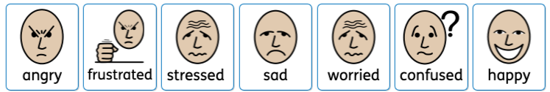
You can share advice with a parent or trusted adult by having accounts together.

You can tell Ollee how you’re feeling and it will give you ideas about what to do.

Even if you’re not sure, Ollee will help you figure it out.

Ollee’s ready to talk. Try it out now here or visit app.ollee.org.uk

