How things make you feel:
Ollee activities to do at home

Talking about your feelings is not always easy.

It’s important to get support when you need it.

Ollee is an app to help you do this.

You can use Ollee to get help with how you’re feeling. It could be you need help with school, family, friends or your body... There are lots to choose from.

You will answer some questions to help you get help about these feelings. Ollee gives you ideas and advice as well.

You can use Ollee with your parent or trusted adult by opening and connecting accounts.

By each having an account, Ollee can help you have those tricky chats.

Ollee’s ready. Try it out now.

This pack has some ideas to help you have these conversations as a family.

Ask a parent to help you – and see what you find out about your feelings.

Activity 1: Power up those feelings

Together, what makes you feel [insert angry face]?
What makes you feel [insert happy face]?
(repeat for each emoticon on the feelings scale)

Discuss what makes you feel better.
It could be,for example:
“I’ve fallen out with a friend” or “I’m finding it hard at school”

How could you answer?

Discuss:
What emotion would you be on the feelings scale after your answer?

Activity 2: Connect and chat

There may be lots of things going on in your life.

If you might find it hard to talk to your parent, here’s what to do:

1: Download the Ollee app on your device and onto your parents device

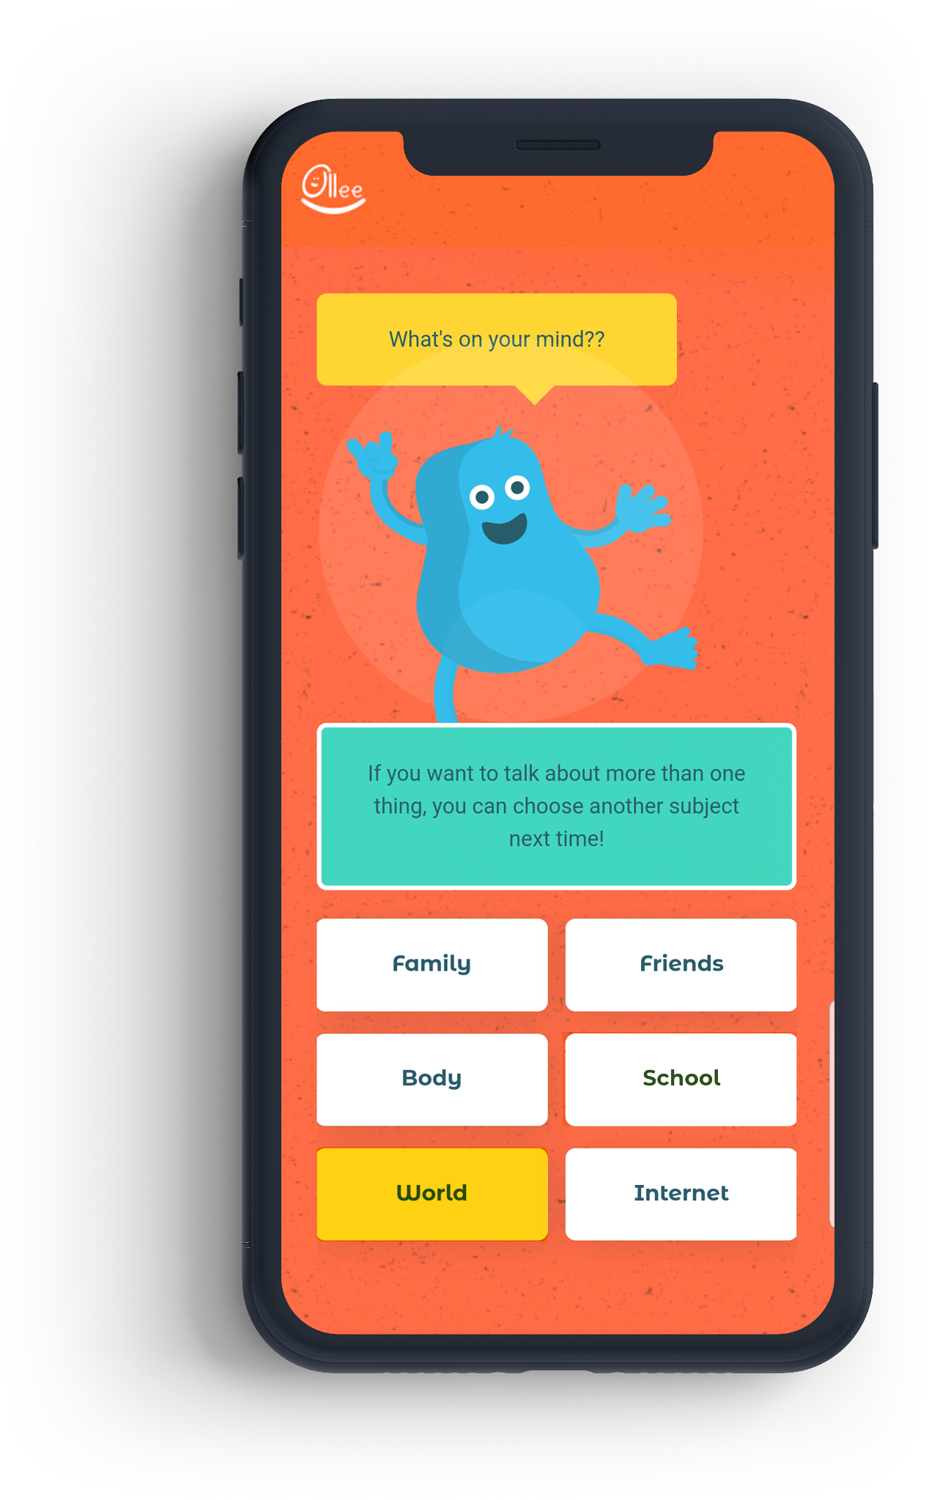

The app can then talk you through connecting your accounts.

2: When you’re connected, look through the different subjects in the app.

Choose a subject and a feeling.

Find one piece of good advice and share it with your parent.

3: Talk together about your feelings.

Ask your parent to do the same and find some advice to share with you.

Could you do this more often and find ways to have chats with Ollee’s help?

Activity 3: Your Ollee feelings diary

Could you keep an Ollee diary to keep track of your feelings over a day, a week or even longer?

Choose a feeling and stick in your diary below

Monday

Tuesday

Wednesday

Thursday

Friday

Saturday

Sunday

Talk to a parent about your feelings.

You could also have a look at what the Ollee app says about them.

Keeping a feelings diary can help you work out if something is bothering you – and maybe find a way to fix it.

When you open an Ollee account with your parent, you can connect them to save and share advice.

Maybe you could save the best advice – along with how you feel – in your Ollee diary in the app?

