Critical Thinking Skills (text only)

Use your critical thinking skills to decide what to do if these things happen....

- Your teacher has set you some research homework. What should you remember?
  - Everything online is true so you can use any website to find answers.
  - Some websites may have false or unreliable information, so you need to be careful.

- Someone in a game chat starts to be really rude to you.
  - Argue back. It's your game after all!
  - Get help muting them so you don't have to hear them – and report them.

- What should you do if you come across something upsetting online?
  - Show the photo to a friend so they know about it too.
  - Tell a trusted grown-up so they can help you.
Critical Thinking Skills (text and widget symbols)

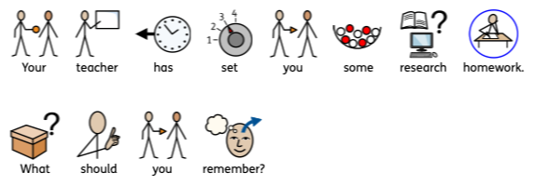
Use your critical thinking skills to decide what to do if these things happen....

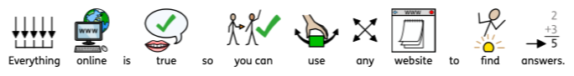
a.

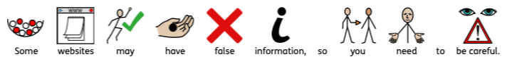
b.

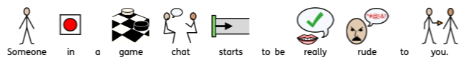
2.

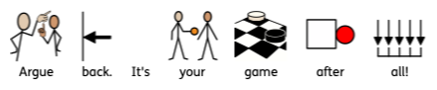
a.

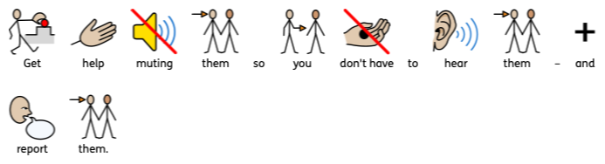
b.

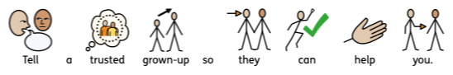
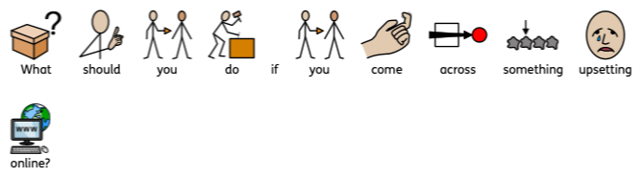
3.

a.

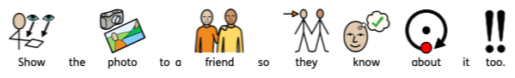
b.

